History of Vebko

Vebko (a knowledge-based company) was founded in 2014. Its first industrial product entered the market in mid-2015, and to date more than 850 relay testers have been delivered to major organizations in the power, oil, and gas industries as well as universities. AMT is a general solution for testing a wide range of devices—protective relays, power transformers, current transformers (CT), voltage and capacitive-voltage transformers (VT/CVT), circuit breakers, cables, and temperature sensors—and, with the features below, provides the capacity needed to test diverse relays and protective equipment.
AMT205 offers six 32-A current sources (64 A three-phase, 128 A single-phase; up to 70 A three-phase and 200 A single-phase for less than 300 ms), six 300-V voltage sources (up to 1200 V single-phase), integrated current and voltage outputs, 8 binary/analog inputs, 2 high-accuracy analog current/voltage inputs, 4 binary outputs, and a DC voltage source (up to 420 V).
AMT105 provides six 32-A current sources (64 A three-phase, 128 A single-phase), four 150-V voltage sources (up to 450 V single-phase), integrated current and voltage outputs, 8 binary/analog inputs, 2 high-accuracy analog current/voltage inputs, 4 binary outputs, and a DC voltage source (up to 212 V).

Introduction

Leveraging advanced technology in its R&D process has enabled VEBKO to set high standards for advanced secondary testing equipment in terms of flexibility, accuracy, portability, and reliability.
Users can select the most suitable device from the AMT test family based on their needs in this field.
Several options are available for working with AMT devices:
- AMT105—with precise measurement and signal injection—meets the needs of relay and protection specialists for common relay and related equipment tests.
- AMT205, using the latest engineering methods, provides precise, high-power signal measurement and generation over a wide range of values, along with IEC 61850 protocol testing, delivering a complete package of capabilities for professionals in this domain.
- AMT103 and AMT203, by omitting certain hardware features of AMT105/AMT205, retain several core modules of the base units to cover routine relay tests.
The powerful AMPRO PC software—featuring optimized test rooms for different applications and a protection test library (XRIO)—offers a vast set of capabilities. Flexible composition of these modules in test plans enables time-saving automation. With Transient Simulation, users can readily perform deeper tests thanks to a system-based approach with internal network simulation. AMT Quick provides a convenient option for manual testing, ideal for quick and simple checks.
Control of AMT test equipment is possible via wired Ethernet, USB, or Wi-Fi.

AMT105
AMT105 is an excellent choice for test engineers to evaluate protective devices with sufficient precision. It features six current outputs up to 32 A and three voltage outputs at 150 V, and—with a low weight of just 13 kg—it is well-suited for testing various equipment in power substations.

AMT205
AMT205 extends capabilities in several directions: generating very small-amplitude signals, measuring signals from micro-level values up to several hundred units, producing large-amplitude signals, and expanding data-centric testing of equipment—overcoming the limitations of the AMT105 in these areas.
This unit includes six 32-A current sources and six 300-V voltage sources. In addition to these features, current and voltage sources can be reconfigured with respect to each other, enabling generation of very small current and voltage signals at very high power.

AMT103 – AMT203
These devices, while retaining certain signal-generation and measurement modules from their parent units, cover a subset of routine tests—thus providing a cost-effective option for engineers who do not require the full feature set.
- AMT103: 4×150 – 3×32, 4 Binary/Analog Input, 4 Binary Output, 2 AC/DC Input
- AMT203: 3×300 – 3×32, 4 Binary/Analog Input, 4 Binary Output, 2 AC/DC Input

Device and software equipment classification

Given the features and capabilities of each device, and the suite of test rooms available in the AMPRO software, these capabilities have different potentials on the AMT105 and AMT205. In AMPRO, they are categorized as Simple, Advanced, and Full Access so that users of each device can work with the functions according to their application needs and the level they have purchased.

Category | Test Options | AMT105 |  |  |  |  |  |  |  |  |  | AMT205
Category | Test Options | Simple | Digital Tester | Traditional Tester | Digital Tester & Traditional Tester | Instrument Tester | Traditional Tester and Instrument Tester | Instrument Tester and Traditional & Digital Tester | PMU Tester | Full Version | Custom | Simple | Digital Tester | Traditional Tester | Digital Tester & Traditional Tester | Instrument Tester | Traditional Tester and Instrument Tester | Instrument Tester and Traditional & Digital Tester | PMU Tester | Full Version | Custom
General Test | Sequencer | ✔ | ✔ | ✔ | ✔ | ✔ | ✔ | ✔ | ✔ | ✔ | ✔ | ✔ | ✔ | ✔ | ✔ | ✔ | ✔ | ✔ | ✔ | ✔ | ✔
General Test | Quick | ✔ | ✔ | ✔ | ✔ | ✔ | ✔ | ✔ | ✔ | ✔ | ✔ | ✔ | ✔ | ✔ | ✔ | ✔ | ✔ | ✔ | ✔ | ✔ | ✔
General Test | Transient | ✔ | ✔ | ✔ | ✔ | ✔ | ✔ | ✔ | ✔ | ✔ | ✔ | ✔ | ✔ | ✔ | ✔ | ✔ | ✔ | ✔ | ✔ | ✔ | ✔
General Test | Harmonic Order | ✔ | ✔ | ✔ | ✔ | ✔ | ✔ | ✔ | ✔ | ✔ | ✔ | ✔ | ✔ | ✔ | ✔ | ✔ | ✔ | ✔ | ✔ | ✔ | ✔
General Test | VCC | ✔ | ✔ | ✔ | ✔ | ✔ | ✔ | ✔ | ✔ | ✔ | ✔ | ✔ | ✔ | ✔ | ✔ | ✔ | ✔ | ✔ | ✔ | ✔ | ✔
Traditional Relay Test | Distance | ❌ | ❌ | ✔ | ✔ | ❌ | ✔ | ✔ | ❌ | ✔ | ‽ | ❌ | ❌ | ✔ | ✔ | ❌ | ✔ | ✔ | ❌ | ✔ | ‽
Traditional Relay Test | Differential | ❌ | ❌ | ✔ | ✔ | ❌ | ✔ | ✔ | ❌ | ✔ | ‽ | ❌ | ❌ | ✔ | ✔ | ❌ | ✔ | ✔ | ❌ | ✔ | ‽
Traditional Relay Test | Differential (Harmonics) | ❌ | ❌ | ✔ | ✔ | ❌ | ✔ | ✔ | ❌ | ✔ | ‽ | ❌ | ❌ | ✔ | ✔ | ❌ | ✔ | ✔ | ❌ | ✔ | ‽
Traditional Relay Test | VIStarting | ❌ | ❌ | ✔ | ✔ | ❌ | ✔ | ✔ | ❌ | ✔ | ‽ | ❌ | ❌ | ✔ | ✔ | ❌ | ✔ | ✔ | ❌ | ✔ | ‽
Traditional Relay Test | Overcurrent | ❌ | ❌ | ✔ | ✔ | ❌ | ✔ | ✔ | ❌ | ✔ | ‽ | ❌ | ❌ | ✔ | ✔ | ❌ | ✔ | ✔ | ❌ | ✔ | ‽
Traditional Relay Test | Transducer | ❌ | ❌ | ✔ | ✔ | ❌ | ✔ | ✔ | ❌ | ✔ | ‽ | ❌ | ❌ | ✔ | ✔ | ❌ | ✔ | ✔ | ❌ | ✔ | ‽
Traditional Relay Test | Synchronizer | ❌ | ❌ | ✔ | ✔ | ❌ | ✔ | ✔ | ❌ | ✔ | ‽ | ❌ | ❌ | ✔ | ✔ | ❌ | ✔ | ✔ | ❌ | ✔ | ‽
Traditional Relay Test | Rogowski Test | ❌ | ❌ | ❌ | ❌ | ❌ | ✔ | ✔ | ❌ | ❌ | ‽ | ❌ | ❌ | ❌ | ✔ | ❌ | ✔ | ✔ | ❌ | ✔ | ‽
Traditional Relay Test | Overcurrent Quick Test | ❌ | ❌ | ❌ | ✔ | ❌ | ✔ | ✔ | ❌ | ✔ | ‽ | ❌ | ❌ | ❌ | ✔ | ❌ | ✔ | ✔ | ❌ | ✔ | ‽
Traditional Relay Test | U/O Voltage Test | ❌ | ❌ | ❌ | ✔ | ❌ | ✔ | ✔ | ❌ | ✔ | ‽ | ❌ | ❌ | ❌ | ✔ | ❌ | ✔ | ✔ | ❌ | ✔ | ‽
Digital Relay Test (IEC61850) | Sample Value | ❌ | ✔ | ✔ | ✔ | ❌ | ❌ | ✔ | ❌ | ❌ | ‽ | ❌ | ✔ | ❌ | ✔ | ❌ | ✔ | ✔ | ❌ | ✔ | ‽
Digital Relay Test (IEC61850) | Goose message | ❌ | ✔ | ✔ | ✔ | ❌ | ❌ | ✔ | ❌ | ✔ | ‽ | ❌ | ✔ | ❌ | ✔ | ❌ | ✔ | ✔ | ❌ | ✔ | ‽
Manufacturer Relay Test | Function Test | ❌ | ❌ | ❌ | ✔ | ❌ | ✔ | ✔ | ❌ | ✔ | ‽ | ❌ | ❌ | ❌ | ✔ | ❌ | ✔ | ✔ | ❌ | ✔ | ‽
Manufacturer Relay Test | Execute Relay Test | ❌ | ❌ | ❌ | ✔ | ❌ | ✔ | ✔ | ❌ | ✔ | ‽ | ❌ | ❌ | ✔ | ✔ | ❌ | ✔ | ✔ | ❌ | ✔ | ‽
Instrument Test | Current Transformer | ❌ | ❌ | ❌ | ❌ | ✔ | ✔ | ✔ | ❌ | ✔ | ‽ | ❌ | ❌ | ❌ | ❌ | ✔ | ❌ | ✔ | ❌ | ✔ | ‽
Instrument Test | Circuit Breaker | ❌ | ❌ | ❌ | ❌ | ✔ | ✔ | ✔ | ❌ | ✔ | ‽ | ❌ | ❌ | ❌ | ❌ | ✔ | ❌ | ✔ | ❌ | ✔ | ‽
Instrument Test | Capacitor Voltage Transformer | ❌ | ❌ | ❌ | ❌ | ✔ | ✔ | ✔ | ❌ | ✔ | ‽ | ❌ | ❌ | ❌ | ❌ | ✔ | ❌ | ✔ | ❌ | ✔ | ‽
Instrument Test | Transformer | ❌ | ❌ | ❌ | ❌ | ✔ | ✔ | ✔ | ❌ | ✔ | ‽ | ❌ | ❌ | ❌ | ❌ | ✔ | ❌ | ✔ | ❌ | ✔ | ‽
Instrument Test | Resistance | ❌ | ❌ | ❌ | ❌ | ✔ | ✔ | ✔ | ❌ | ✔ | ‽ | ❌ | ❌ | ❌ | ❌ | ✔ | ❌ | ✔ | ❌ | ✔ | ‽
Instrument Test | RTD | ❌ | ❌ | ❌ | ❌ | ✔ | ✔ | ✔ | ❌ | ✔ | ‽ | ❌ | ❌ | ❌ | ❌ | ✔ | ❌ | ✔ | ❌ | ✔ | ‽
Instrument Test | AR | ❌ | ❌ | ❌ | ❌ | ✔ | ✔ | ✔ | ❌ | ✔ | ‽ | ❌ | ❌ | ❌ | ❌ | ✔ | ❌ | ✔ | ❌ | ✔ | ‽
Instrument Test | RGround | ❌ | ❌ | ❌ | ❌ | ✔ | ✔ | ✔ | ❌ | ✔ | ‽ | ❌ | ❌ | ❌ | ❌ | ✔ | ❌ | ✔ | ❌ | ✔ | ‽
PMU | Phasor Measurement Unit(PMU) | ❌ | ❌ | ✔ | ✔ | ❌ | ❌ | ❌ | ✔ | ✔ | ‽ | ❌ | ❌ | ✔ | ✔ | ❌ | ❌ | ❌ | ✔ | ✔ | ‽
Electronic Relay Test | Test Template | ❌ | ❌ | ❌ | ✔ | ❌ | ✔ | ✔ | ❌ | ✔ | ‽ | ❌ | ❌ | ❌ | ✔ | ❌ | ✔ | ✔ | ❌ | ✔ | ‽

Category | Test Options | AMT103 |  |  |  |  |  |  |  |  |  | AMT203
Category | Test Options | Simple | Digital Tester | Traditional Tester | Digital Tester & Traditional Tester | Instrument Tester | Traditional Tester and Instrument Tester | Instrument Tester and Traditional & Digital Tester | PMU Tester | Full Version | Custom | Simple | Digital Tester | Traditional Tester | Digital Tester & Traditional Tester | Instrument Tester | Traditional Tester and Instrument Tester | Instrument Tester and Traditional & Digital Tester | PMU Tester | Full Version | Custom
General Test | Sequencer | ✔ | ✔ | ✔ | ✔ | ✔ | ✔ | ✔ | ✔ | ✔ | ✔ | ✔ | ✔ | ✔ | ✔ | ✔ | ✔ | ✔ | ✔ | ✔ | ✔
General Test | Quick | ✔ | ✔ | ✔ | ✔ | ✔ | ✔ | ✔ | ✔ | ✔ | ✔ | ✔ | ✔ | ✔ | ✔ | ✔ | ✔ | ✔ | ✔ | ✔ | ✔
General Test | Transient | ❌ | ❌ | ❌ | ❌ | ❌ | ❌ | ❌ | ❌ | ✔ | ✔ | ❌ | ❌ | ❌ | ❌ | ❌ | ❌ | ❌ | ❌ | ✔ | ✔
General Test | Harmonic Order | ✔ | ✔ | ✔ | ✔ | ✔ | ✔ | ✔ | ✔ | ✔ | ✔ | ✔ | ✔ | ✔ | ✔ | ✔ | ✔ | ✔ | ✔ | ✔ | ✔
General Test | VCC | ✔ | ✔ | ✔ | ✔ | ✔ | ✔ | ✔ | ✔ | ✔ | ✔ | ✔ | ✔ | ✔ | ✔ | ✔ | ✔ | ✔ | ✔ | ✔ | ✔
Traditional Relay Test | Distance | ❌ | ❌ | ✔ | ✔ | ❌ | ✔ | ✔ | ❌ | ✔ | ‽ | ❌ | ❌ | ✔ | ✔ | ❌ | ✔ | ✔ | ❌ | ✔ | ‽
Traditional Relay Test | Differential | ❌ | ❌ | ✔ | ✔ | ❌ | ✔ | ✔ | ❌ | ✔ | ‽ | ❌ | ❌ | ✔ | ✔ | ❌ | ✔ | ✔ | ❌ | ✔ | ‽
Traditional Relay Test | Differential (Harmonics) | ❌ | ❌ | ✔ | ✔ | ❌ | ✔ | ✔ | ❌ | ✔ | ‽ | ❌ | ❌ | ✔ | ✔ | ❌ | ✔ | ✔ | ❌ | ✔ | ‽
Traditional Relay Test | VIStarting | ❌ | ❌ | ✔ | ✔ | ❌ | ✔ | ✔ | ❌ | ✔ | ‽ | ❌ | ❌ | ✔ | ✔ | ❌ | ✔ | ✔ | ❌ | ✔ | ‽
Traditional Relay Test | Overcurrent | ❌ | ❌ | ✔ | ✔ | ❌ | ✔ | ✔ | ❌ | ✔ | ‽ | ❌ | ❌ | ✔ | ✔ | ❌ | ✔ | ✔ | ❌ | ✔ | ‽
Traditional Relay Test | Transducer | ❌ | ❌ | ❌ | ❌ | ❌ | ❌ | ❌ | ❌ | ✔ | ‽ | ❌ | ❌ | ❌ | ❌ | ❌ | ❌ | ❌ | ❌ | ✔ | ‽
Traditional Relay Test | Synchronizer | ❌ | ❌ | ✔ | ✔ | ❌ | ✔ | ✔ | ❌ | ✔ | ‽ | ❌ | ❌ | ✔ | ✔ | ❌ | ✔ | ✔ | ❌ | ✔ | ‽
Traditional Relay Test | Rogowski Test | ❌ | ❌ | ❌ | ❌ | ❌ | ✔ | ✔ | ❌ | ❌ | ‽ | ❌ | ❌ | ❌ | ✔ | ❌ | ✔ | ✔ | ❌ | ✔ | ‽
Traditional Relay Test | Overcurrent Quick Test | ❌ | ❌ | ❌ | ✔ | ❌ | ✔ | ✔ | ❌ | ✔ | ‽ | ❌ | ❌ | ❌ | ✔ | ❌ | ✔ | ✔ | ❌ | ✔ | ‽
Traditional Relay Test | U/O Voltage Test | ❌ | ❌ | ❌ | ✔ | ❌ | ✔ | ✔ | ❌ | ✔ | ‽ | ❌ | ❌ | ❌ | ✔ | ❌ | ✔ | ✔ | ❌ | ✔ | ‽
Digital Relay Test (IEC61850) | Sample Value | ❌ | ✔ | ✔ | ✔ | ❌ | ❌ | ✔ | ❌ | ❌ | ‽ | ❌ | ✔ | ❌ | ✔ | ❌ | ✔ | ✔ | ❌ | ✔ | ‽
Digital Relay Test (IEC61850) | Goose message | ❌ | ✔ | ✔ | ✔ | ❌ | ❌ | ✔ | ❌ | ✔ | ‽ | ❌ | ✔ | ❌ | ✔ | ❌ | ✔ | ✔ | ❌ | ✔ | ‽
Manufacturer Relay Test | Function Test | ❌ | ❌ | ❌ | ✔ | ❌ | ✔ | ✔ | ❌ | ✔ | ‽ | ❌ | ❌ | ❌ | ✔ | ❌ | ✔ | ✔ | ❌ | ✔ | ‽
Manufacturer Relay Test | Execute Relay Test | ❌ | ❌ | ❌ | ✔ | ❌ | ✔ | ✔ | ❌ | ✔ | ‽ | ❌ | ❌ | ✔ | ✔ | ❌ | ✔ | ✔ | ❌ | ✔ | ‽
Instrument Test | Current Transformer | ❌ | ❌ | ❌ | ❌ | ❌ | ❌ | ❌ | ❌ | ❌ | ‽ | ❌ | ❌ | ❌ | ❌ | ❌ | ❌ | ❌ | ❌ | ❌ | ‽
Instrument Test | Circuit Breaker | ❌ | ❌ | ❌ | ❌ | ❌ | ❌ | ❌ | ❌ | ❌ | ‽ | ❌ | ❌ | ❌ | ❌ | ❌ | ❌ | ❌ | ❌ | ❌ | ‽
Instrument Test | Capacitor Voltage Transformer | ❌ | ❌ | ❌ | ❌ | ❌ | ❌ | ❌ | ❌ | ❌ | ‽ | ❌ | ❌ | ❌ | ❌ | ❌ | ❌ | ❌ | ❌ | ❌ | ‽
Instrument Test | Transformer | ❌ | ❌ | ❌ | ❌ | ❌ | ❌ | ❌ | ❌ | ❌ | ‽ | ❌ | ❌ | ❌ | ❌ | ❌ | ❌ | ❌ | ❌ | ❌ | ‽
Instrument Test | Resistance | ❌ | ❌ | ❌ | ❌ | ❌ | ❌ | ❌ | ❌ | ❌ | ‽ | ❌ | ❌ | ❌ | ❌ | ❌ | ❌ | ❌ | ❌ | ❌ | ‽
Instrument Test | RTD | ❌ | ❌ | ❌ | ❌ | ❌ | ❌ | ❌ | ❌ | ❌ | ‽ | ❌ | ❌ | ❌ | ❌ | ❌ | ❌ | ❌ | ❌ | ❌ | ‽
Instrument Test | AR | ❌ | ❌ | ❌ | ❌ | ❌ | ❌ | ❌ | ❌ | ❌ | ‽ | ❌ | ❌ | ❌ | ❌ | ❌ | ❌ | ❌ | ❌ | ❌ | ‽
Instrument Test | RGround | ❌ | ❌ | ❌ | ❌ | ❌ | ❌ | ❌ | ❌ | ❌ | ‽ | ❌ | ❌ | ❌ | ❌ | ❌ | ❌ | ❌ | ❌ | ❌ | ‽
PMU | Phasor Measurement Unit(PMU) | ❌ | ❌ | ✔ | ✔ | ❌ | ❌ | ❌ | ✔ | ✔ | ‽ | ❌ | ❌ | ✔ | ✔ | ❌ | ❌ | ❌ | ✔ | ✔ | ‽
Electronic Relay Test | Test Template | ❌ | ❌ | ❌ | ✔ | ❌ | ✔ | ✔ | ❌ | ✔ | ‽ | ❌ | ❌ | ❌ | ✔ | ❌ | ✔ | ✔ | ❌ | ✔ | ‽

AMPRO

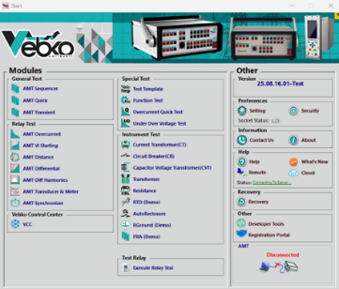
The powerful AMPRO software for Windows unleashes the full testing potential of the AMT tester. It offers a broad set of optimized test rooms for specific applications, enabling users to achieve a high degree of automation in their testing workflows.
• Functional testing of measurement and specialized protections
AMPRO provides various options for automated testing through dedicated rooms for specific protection functions—such as overcurrent relays, distance (impedance) relays, or differential relays.
In these rooms, graphical visualization of relay characteristics—like current–time (I/t) curves, impedance planes, etc.—allows you to:
• Define test conditions graphically
• Display test results directly on the relay’s characteristic curve
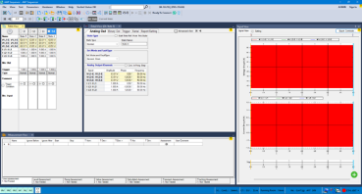
This approach increases accuracy, speed, and the depth of analysis, and customizes tests to the precise characteristics of each relay.
• Testing of general functions
For creating and executing specialized tests that are not covered by the function-specific test rooms, AMPRO also includes the AMT Sequencer general test room.
Such tests can include:
• Multi-state sequences controlled by time or by the behavior of the relay under test, with evaluation based on operate-time measurements
• Linear or pulsed ramping of values, with evaluation based on the pickup or reset point of the relay
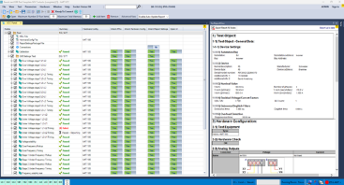
• Manual testing—by numerically setting and applying voltage, current, phase angle, frequency, and more

• VEBKO Control Center (VCC)
To test a range of functions in digital relays, VEBKO Control Center (VCC) makes it possible to combine separate test rooms into a single comprehensive test plan.
During execution:
• Each test room in the plan runs sequentially.
• At the end, a complete report of the results of all tested functions is generated automatically.
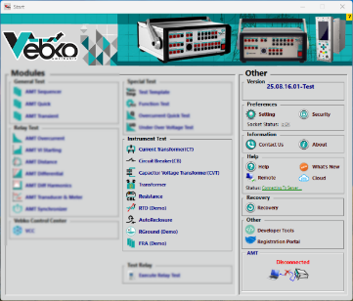
•Instrument Test
One of the key advantages of the AMT device is its capability to perform a variety of tests on protective apparatus, including:
• Current Transformer • Capacitor Voltage Transformer
•Circuit Breaker • Transformer
alongside impedance and ground-resistance testing.
In these tests, the device measures the actual values of injected signals and the precise values of the signals returned from the device under test, ensuring highly accurate results.
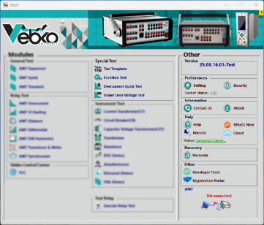
To carry out these tests, the software provides a default wiring/connection scheme that can be modified according to set values and test conditions, giving users full flexibility to configure the equipment’s test conditions.

•Special Test
In the Special Test section, rooms are designed for a set of specific, limited tests that spare users from repeatedly creating time-consuming designs for narrow tasks. These rooms include:
• Test Template • Over Current Quick Test
• Under Over Voltage • Function Test

Each of these advances the test automation process in its own way.

AMT Sequencer

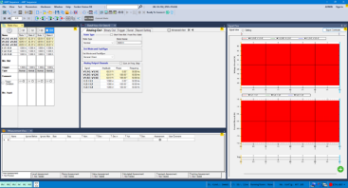
AMT Sequencer is a highly flexible test room for evaluating the performance of relays and other electrical equipment. A state is defined with specific signals (voltages and currents, binary outputs) and with conditions for transitioning to the next state. Multiple distinct states can be arranged sequentially to form a complete test sequence. Transition from one state to the next may occur after a fixed time, manually, or upon a trigger condition occurring on the binary inputs.

Definition of individual states

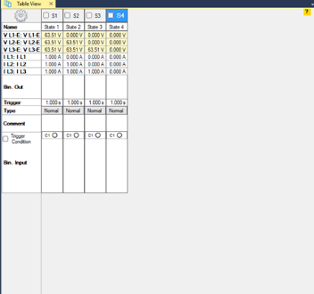
In a given state, all configured test signals of the test set (voltage and current outputs) can be adjusted independently in amplitude, phase, and frequency.
Beyond entering voltages and currents directly, the software can compute other derived parameters, such as symmetrical components, impedance values, and bias/differential currents.
In addition to direct voltage and current inputs, the software can also accept inputs in terms of fault quantities, power quantities, symmetrical components, or impedances (with constant test current, constant test voltage, or a fixed source-impedance model).
For distance relays, test points can be defined directly on the impedance plane that displays the relay’s nominal characteristic.

Assessment and Analyzing

In the software, measurement conditions are displayed in a table. After the test is executed, this table also includes the actual measured times, deviations, and the automatic evaluation of results. The last column indicates whether each item passed or failed.
All signals (voltages, currents, and binary inputs) can be displayed graphically to facilitate relay performance analysis. Signals can be enabled individually, and zooming is available at specific time points. Data cursors allow precise navigation through the time-domain signals and viewing of values at selected times.

Quick
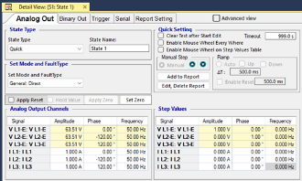
Quick, while providing a simple user interface, offers powerful capabilities for performing manual tests—tests that can be used for a wide range of protective relays, measurement transducers, and other equipment.

Continuous Ramp, Step Ramp

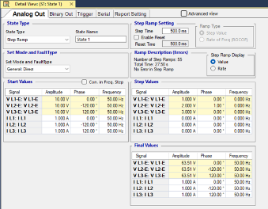
Ramp mode is used to determine threshold values such as a relay’s pick-up and drop-off. In Ramp mode, the selected quantities (e.g., current, voltage, impedance, power, etc.) are increased or decreased by a specified increment at defined time intervals. The same step is applied continuously and repeatedly until an input changes state.

Harmonics

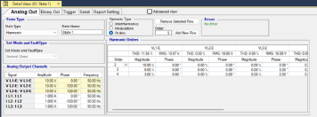
Harmonics generates test signals that include the fundamental voltage or current component along with added harmonics. This feature enables signal generation up to 1 kHz on the AMT105, and up to 2.5 kHz on current sources and 10 kHz on voltage sources for the AMT205.
For example: the 60th harmonic in a 50 Hz system, or the 50th harmonic in a 60 Hz system.
Harmonic magnitudes can be entered in two ways:
•As a percentage relative to the fundamental component •As an absolute value
The generated harmonic signals can be:
•Output directly, or •Exported as COMTRADE files.
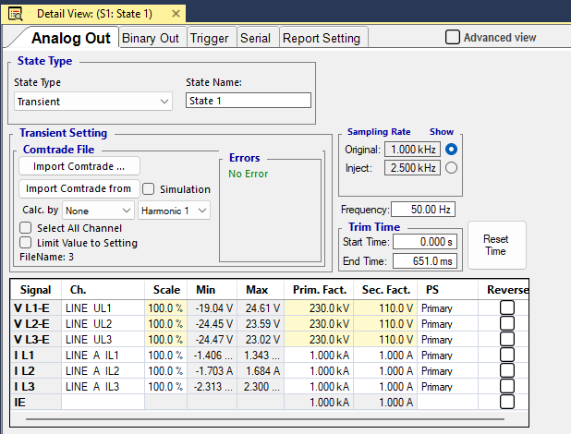
Transient

Transient enables the AMT device to perform tests using transient signals. Transient signal data from sources such as:
•Power-system simulation software •Fault recorders
•Test equipment

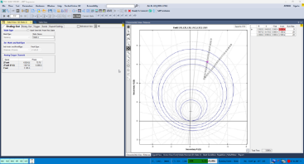
Tracking

Using this module, you can graphically define a trajectory for the impedance or the differential–bias current seen by the relay, thereby making it straightforward to conduct key dynamic tests such as power swing or saturation detection. Its advantages include:
•Simple definition of any desired number of points •Adjustable speed, magnitude, and progression of the parameter under test
•Setting the direction of change for the parameter under test •Support for both impedance and differential testing

AMT Overcurrent

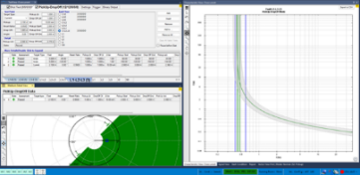
Overcurrent is used for automated testing of directional and non-directional overcurrent relays, in which the trip-time characteristic, the directional boundaries of current stages, and the pick-up/drop-off ratio are evaluated automatically. Owing to the flexible definition of directional boundaries, this capability is also an ideal choice for testing the characteristics of steady-state ground-fault relays.
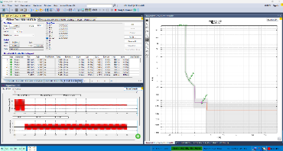
This room supports defining directional sectors and any number of elements, including line-to-line, phase-to-ground, positive-sequence, negative-sequence, and zero-sequence. For each element, the trip characteristic can be selected individually and displayed on both the current–time (I/t) curve and the directional plane.
In the Overcurrent module, a set of test shots can be defined simultaneously for all desired fault loops. This capability applies to the following fault types:
•Line-to-Line Fault •Line-to-Ground Fault

•Negative Sequence •Zero Sequence

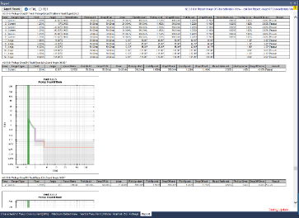
The software overlays the characteristics of each relevant element on both the I/t curve and the directional plot, including all elements that respond to the applied fault type. For each test shot, relay performance is evaluated based on allowable current-measurement and operate-time tolerances.
•Key Features
•Definition of test-point sequences (by fault type, current-magnitude changes, and current-angle changes)
•Performance evaluation for each test shot, considering all active elements •Unified testing of all fault types and loops within a single test module
•Unlimited definition of characteristic elements (characteristic type and directional sector) •Concurrent availability of all element and characteristic types
•Pick-up/Drop-off characteristic testing with automatic evaluation •Option to test with or without load current

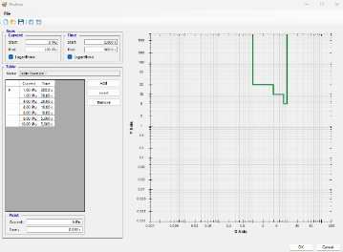
•Automatic reporting
Time characteristics can be entered directly as a current/time table, or selected from a wide range of predefined characteristics for relays and reclosers. Structured, hierarchical templates for relay characteristics include:
•Inverse-time characteristics per IEC 60255-4 (BS 142) •IAC-type characteristics
•Relay-specific curves based on the IEEE equation (standard PC37.112)

Variants of these characteristics support common relay types. Additional variants can also be added to the template file, including curves digitized using the Overcurrent Characteristics Grabber tool (explained later).

•Overcurrent Characteristics Grabber
The Overcurrent Characteristics Grabber tool is a companion to the Overcurrent test module. It helps extract inverse-time overcurrent relay trip characteristics from graphical representations. This is especially useful when the relay’s characteristic is not provided as a formula and is available only as a plot (e.g., an image in the relay’s user manual).

AMT Distance

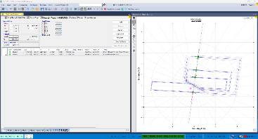
Distance module enables defining and executing distance-relay tests by evaluating impedance elements. The process is performed using single-shot definitions on the impedance plane (Z-plane) with graphical visualization of characteristics. It also provides:
•Search and Check tests for determining zone reaches
•Alignment of test parameters to zone reaches and line angle using relative shots
•Constant Source Impedance test model

•Shot test, Search test, and Check test
•Shot test: Test points are added individually to the points table and processed automatically.
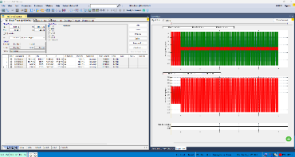
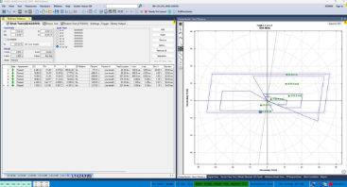
•Search test: Zone reach limits are determined automatically. This is done by scanning along search lines defined on the impedance plane, using an optimized algorithm. You can define a set of search lines; all defined lines are saved in a table and processed automatically.
•Check test: Test points are automatically placed on the zone tolerance boundaries. This setup uses check lines similar to search lines; however, in this case the test points are positioned only at the intersections of the check lines with the zone tolerance boundaries. Check is an efficient method for overall relay testing with minimal test time, enabling quick compliance verification—especially useful for routine tests.

•Relative test definitions
One of the system’s powerful capabilities is defining test points relative to the nominal characteristic of the distance relay (e.g., 90% of Zone 1, 110% of Zone 1, 90% of Zone 2, etc.). In this approach, test points are not entered as absolute R, X, Z, or angle values; instead, they are defined by their relative position with respect to the zone reaches and the line angle.
This capability enables creation of reusable test templates that automatically align with the relay’s actual settings, eliminating the need to redefine test points for each new relay.
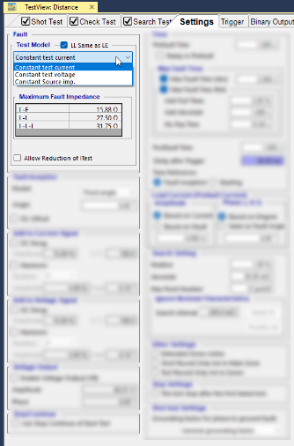
•Constant source impedance model
In addition to the constant test current and constant test voltage models, the Distance module also provides a constant source impedance test model. This is particularly useful in cases where parameters such as the Source Impedance Ratio (SIR) are important.

•Testing multiple fault loops in a single test module
The Distance module provides dedicated support to run tests for multiple fault loops—such as line-to-ground (L-N), line-to-line (L-L), and three-phase (L-L-L)—within a single test room.
Separate tabs are provided for all test modes (Shot, Search, Check), each with its own test-points table for the corresponding fault type. Test settings can be entered specifically for each fault loop or defined simultaneously for multiple fault types.

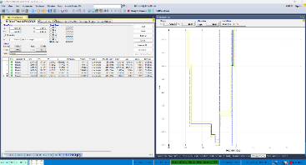
•Z/t Diagram
This chart displays the graded trip time curve as a function of impedance along a specified line. The line can be defined either on the impedance plane or selected from the test tables. You can also define test points and view the evaluation results directly on this chart.

AMT VI Starting

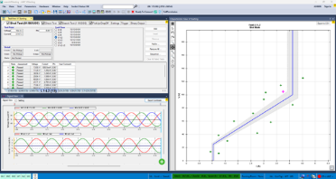
VI Starting room tests the Voltage-Dependent Overcurrent Starting Characteristic, which is used in many distance relays. It is also an ideal tool for performing various tests on overcurrent and undervoltage functions.
For each specified test point, this module automatically determines the pick-up, drop-off, and their ratio.
Benefits
• Ability to define separate characteristics for phase-to-ground and phase-to-phase faults • Automatic identification of characteristics
• Intuitive UI with graphical test visualization • Automated test execution based on define characteristics
• Clear presentation of results in tables and plots • Automatic determination of pick-up and drop-off values

AMT Differential

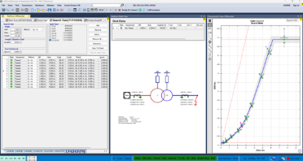
A set of test tabs that provides a comprehensive solution for testing differential protection schemes.
These tabs are especially well-suited for transformer differential protection with up to three windings and up to six injected currents.
Advanced modeling of the protected equipment (e.g., power transformer), secondary equipment (e.g., CTs and their connections), and the relay’s protection characteristics supplies the data required for the test calculations.
Automatic calculation of test currents eliminates complex, time-consuming, and error-prone manual work, making relay testing simpler, faster, and more cost-effective.Main capabilities of this test solution:
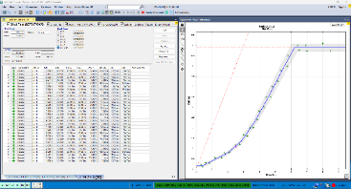
• •Support for all fault types: line-to-ground (L–N), line-to-line (L–L), three-phase (L–L–L)
• •Ability to run Shot tests at predefined points and Search tests to determine zone reach
• •Automatic evaluation and analysis of results against nameplate specs and defined tolerances
• •Automatic reporting with graphical presentation of results on the characteristic curve
• •No need to block voltage-dependent functions
• •Synchronization of all shots with time references such as PTP, GPS, or IRIG-B

Key capabilities for testing multifunction relays
• Magnitude and phase correction for higher accuracy • Fault type
• Transformer nameplate data and vector group • Load current
•Fault/feed side (primary, secondary, …) • CT ratios and connection scheme

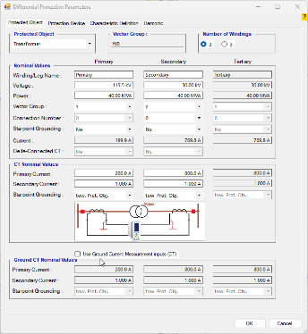
Evaluation of protective-relay performance based on:
•Relay operating characteristic (Operating Characteristic) • Zero-sequence elimination (Zero Sequence Elimination
• Bias calculation (Bias Calculation)
•Other features
•Support for controlling up to 6 injected currents for convenient testing of three-winding transformer differential protection
•Support for non-transformer applications, such as generator differential-protection testing (no transformer model required)

AMT Synchronizer

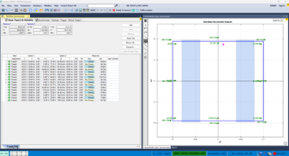
Synchronizer module simulates two systems for the synchronization process:
•System 1 (representing the mains) is defined with fixed amplitude and frequency.
•System 2 (representing the generator or the system being synchronized) has variable amplitude and frequency and is controlled.

Performance and evaluation of synchronization
•The software automatically detects the CB closing command from the synchronizer device or Synchro-Check relay, and—taking the CB closing time into account—checks whether synchronization occurred within the permissible synchronizing window.
Control of the second system (generator)
•The amplitude and frequency of the second system can vary linearly according to the generator’s time constant.
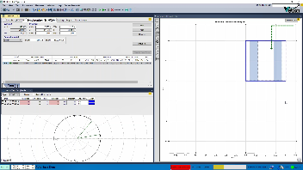
•The second output can be controlled in steps (ramping).
•For auto-tuning synchronizers, the following control commands can be used to control the second system’s voltage output:
• Increase/Decrease voltage (V↑, V↓) • Increase/Decrease frequency (f↑, f↓)

Dynamic simulation and monitoring
•Dynamic generator models are available for more realistic conditions.
•Binary command sequences (for voltage and frequency adjustment) and changes in voltage and frequency are monitored graphically, making the synchronization process clearly visible.
•The synchronoscope implemented in Vector View displays the rotating voltage vector of the second system and indicates the exact instant of synchronization.

AMT Transducer & Meter

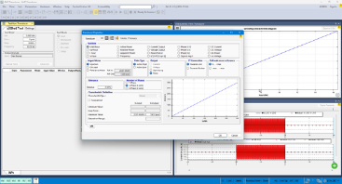
Transducers & Meters enable connection to the device for manual or automated testing of various measurement functions, including:
• Active power (single-phase or three-phase) • Frequency
• Reactive power (single-phase or three-phase) • Current
• Apparent power (single-phase or three-phase) • Phase angle
• DC quantities (current, voltage, power) • Var-hours
• Power factor (cos φ) • Watt-hours
•Signed average of currents • Ampere-hours
• DC quantities (current, voltage, power) •Volt-hours
•Voltage (phase-to-ground, phase-to-phase)
The module can test the following characteristics:
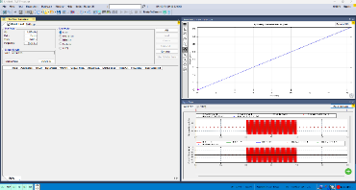
•Quadratic •Symmetrical or asymmetrical
•Linear •Composite

Manual Test mode is used when a measurement transducer needs re-adjustment (re-calibration). In this mode, any desired input quantity can be generated for the transducer. You can also move easily between key points on a characteristic curve and observe the transducer’s error at a given input value.
In Automatic Test, the predefined test-points table is executed sequentially, with documentation and evaluation of results. Here, the test points represent the measurement transducer’s input values. In addition, the transducer’s behavior against changes in input voltage or frequency can optionally be examined.
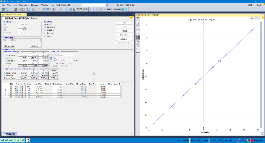
For multifunction meters or meters with two directions of rotation, a separate table (with multiple tabs) is provided for each test function. Test rows can be repeated; in that case, the standard deviation is shown alongside the meter error, which can indicate whether the testing process itself is sound. Test quantities are displayed graphically as phasor diagrams for voltage, current, and power. Testing can be performed with any symmetrical or asymmetrical load, for single-phase meters (or one element of a three-phase meter), and for three-wire or four-wire meters.
To examine meter behavior in the presence of harmonics or DC components, the following current waveforms can be used:
•Sine wave with harmonics (Sine + Harmonics) •Pure sine wave (Sine)
•Sine wave with DC component (Sine + DC)
Phasor Measurement unit

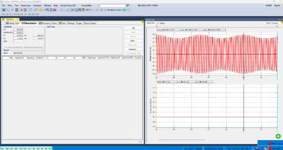
The core operation of a PMU (Phasor Measurement Unit) is based on precise real-time measurement of voltage and current and the computation of phasor parameters. These devices use GPS synchronization to ensure timing accuracy. Accordingly, the test set includes components for simulating real grid conditions, generating standard signals, and verifying synchronization accuracy.
AMPRO will cover the following:
1.Grid-condition simulation: Generates voltage and current signals under various operating conditions—such as load changes, faults, and frequency fluctuations. These signals are applied to the PMU inputs.
2.Output evaluation and comparison: PMU outputs are compared against reference values obtained from the simulations. Any deviation from the reference values may indicate a deficiency or inaccuracy in PMU performance.
3.Stability testing: Designed to assess PMU performance under abnormal conditions and sudden network changes, ensuring correct operation in all scenarios.
4.Timing-synchronization accuracy check: Verifies the PMU’s synchronization accuracy with GPS signals and its impact on the device’s measurement accuracy.
5.Automated testing: The system should support automated execution of tests to improve efficiency and speed, enabling continuous monitoring of PMU performance.

VEBKO CONTROL CENTER(VCC)

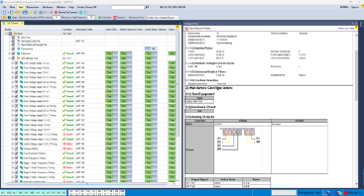
AMPRO software rooms offer comprehensive, advanced capabilities for routine testing of protective equipment. With VEBKO Control Center (VCC), these rooms can be uniquely combined into a single file to form test plans.
•Benefits of this technology
•Fast, standardized distribution and sharing across teams or sites
•Simple maintenance and updates of tests •Easy creation of combined test plans

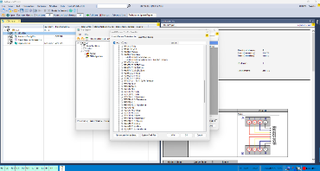
This capability makes AMPRO a highly flexible and powerful tool, enabling complete management of complex, multi-stage tests within a single, unified framework.
In essence, a VCC (VEBKO Control Center) document contains:
•Test object data
In AMPRO, the Test Object is defined using the XRIO format—a powerful environment for describing and modeling the parameters and settings of the device under test.
•Device/I/O/wiring information
Specified in the hardware configuration and available throughout the test plan to all embedded test modules.
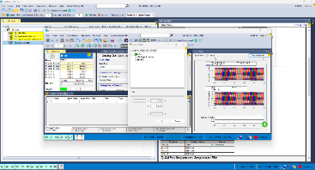
•Test rooms with test settings (test points, etc.)
The number and type of embedded rooms depend on the intended tests. Tests automatically adapt to modified test-object settings, since these are propagated from the overall definition. Using LinkToXRIO, the user can access all relay parameters—including user-defined additions—to define test points and evaluation conditions.
•Charts, help texts, etc. (optional)
Test guidance during execution per the specification (e.g., wiring images, inspection instructions), supported by the Pause Module and Text View.
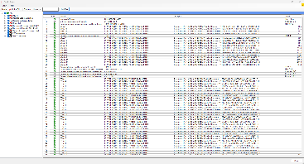
•Test Object definition with XRIO
All data related to a relay’s settings are stored in XRIO. Relevant data can be entered manually or imported. Test-object parameters can also be exported for use in other test plans.
•LinkToXRIO
LinkToXRIO lets test rooms use test-object parameters directly. If a parameter changes, there is no need to modify the test plan; the plan will execute the specified tests with the updated parameter.
•XRIO converters
XRIO converters efficiently transform existing data from relays’ internal parameter structures. The growing library of relay-specific XRIO converters provides data models of protection features and tolerances (e.g., impedance zones, I/t curve shapes, etc.) based on the protection parameters and technical details documented in the device manual.

AMT Current Transformer

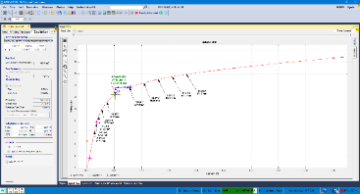
This room comprises a set of dedicated tests for current transformers (CTs), the most important of which are:
•Secondary Burden • Saturation
•Winding Resistance • CT Ratio and Burden

In these tests, by precisely measuring the actual signal values and performing the procedures specific to each test, results are calculated with high accuracy and recorded in the results table.The system is designed so that, by implementing a variety of test methods, it can evaluate a wide range of CT classes and specifications. This approach ensures comprehensive coverage of technical and performance requirements in the testing and validation of CTs.

AMT Circuit Breaker

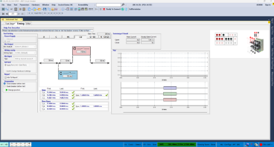
This room provides a comprehensive set of key tests for evaluating circuit breakers, including:
• Dynamic Resistance Measurement (DRM) • Timing Test
• Contact Resistance • Motor Current
• Minimum PickUp
Within each tab, a variety of tests can be executed based on the user’s needs and the type of circuit breaker under test.
Test results are captured with high-speed sampling up to 12.5 microseconds (80 kHz), delivering high accuracy for performance analysis.
Users can define acceptable ranges and parameters, and the software intelligently evaluates and reports results according to these settings.

AMT Transformer

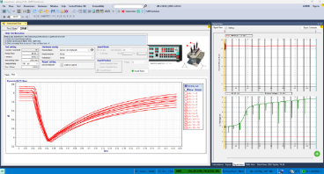
This room supports a wide range of power transformers with various vector groups, voltage levels, and tap-changer types. After entering the transformer nameplate data, the applicable tests are displayed automatically based on the equipment type, and the user can select and run the desired tests.
Key tests available in this room include:
•Vector group check, turns ratio, and no-load current •DC resistance measurement
•Percentage impedance (UK%) measurement •Flux division test
•Dynamic Resistance Measurement (DRM) •Tap continuity assessment
•Vector group verification (Vector Group Check) •No-load current measurement
•Zero-sequence impedance measurement
After all tests are completed, the Demagnetize tab provides transformer demagnetization, helping prevent operational issues during commissioning and service.

AMT Capacitor Voltage Transformer

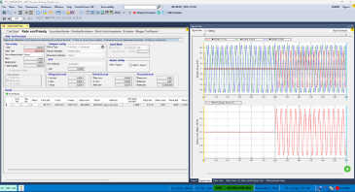
This room comprises a set of specialized tests for capacitive voltage transformers (CVTs), including:
•Secondary Burden •CT Ratio and Burden
•Winding Resistance •Percentage Impedance (UK%)
•Saturation

Each test precisely measures the actual signals and applies dedicated procedures, calculating results accurately and recording them in the results tables.
These tests are designed with diverse methods to provide broad coverage of different CVT classes and specifications, thereby meeting varied technical requirements in CVT testing and evaluation.

AMT Resistance

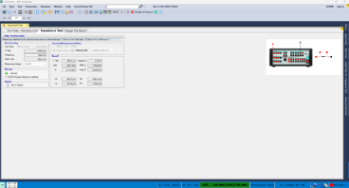
This room also serves as a precise platform for measuring key electrical parameters—including resistance, impedance, inductance, and capacitance. Two dedicated tabs with specialized functionality are provided:
•Resistance tab
Suitable for high-accuracy resistance measurements across various configurations, with the ability to tailor test conditions to the specific equipment or circuit under examination.
•Impedance tab
For measuring impedance, inductance, and capacitance, with support for two common test methods:
•Current injection with voltage measurement •Voltage application with current measurement

This dual-method design offers high flexibility in executing tests and enables measurement of both AC and DC parameters across a wide range of equipment and circuits.

AMT AutoRecloser

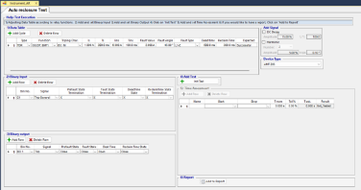
The automatic autorecloser test room—with comprehensive configuration capabilities for defining test plans and standard templates for periodic and repeatable tests—is designed as an efficient platform for validating equipment in power distribution networks. The system supports parametric tests, enabling precise evaluation of autorecloser performance and fully automating test workflows.
Moreover, autoreclosers manufactured by Noja, Tavrida, Entec, Schneider, Nu-Lec, and Eaton Cooper are fully compatible with Vebko AMT, allowing seamless integration and execution of advanced, automated tests. This technical alignment increases equipment reliability, reduces operational errors, and optimizes maintenance and testing processes.
AMT RGround

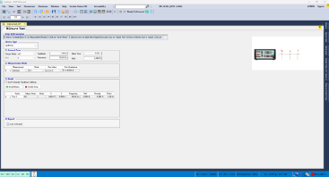
RGround Test Room includes a suite of specialized tests for examining and evaluating the grounding (earthing) system resistance, comprising:
•Earth Resistance Measurement• Earth Loop Resistance Measurement• Grounding System Continuity Test
Using standard methods and precise instrumentation, the actual earth resistance values are measured; each test is then analyzed professionally, and the results are recorded in the corresponding reports.
By implementing multiple measurement methods, a broad range of grounding conditions and system types with varying specifications is covered, enabling accurate evaluation.
These solutions allow engineers and technicians to assess the grounding system comprehensively and to plan corrective actions with high precision.

Test Template

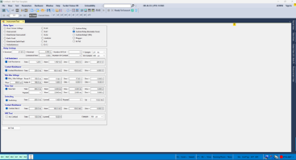
In this test room, a comprehensive and advanced infrastructure has been implemented, enabling a wide range of protection tests.
The user can perform precise, structured tests for current, voltage, directional, and directional earth-fault relays. Evaluation of simple contact-type relays is also supported in this environment.
All tests are executed based on the user’s input settings, and the results are recorded and presented with analytical detail in accordance with the defined parameters.

Function Test

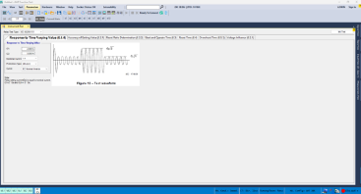
In this section, a set of structured, categorized function tests has been designed and implemented to enable automated testing in accordance with international requirements, meeting the needs of test and operations engineers. This capability plays a key role in obtaining recognized performance certifications.
Currently, the following automated tests are supported in this room:
•Voltage relay testing (IEC 60255-127)

•Current relay testing (IEC 60255-151)
•Directional relay testing (IEC 60255-149)

The test-room infrastructure is designed for dynamic expansion, allowing new standards to be added in the future. Continuous updates make this system a reliable option for performing standards-based tests and for documenting results.

OverCurrent Quick Test

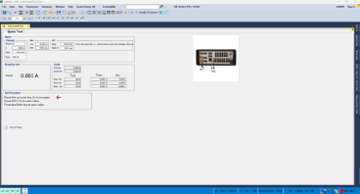
This test room is specifically designed and equipped for electromechanical relays with high burden. The hardware and software infrastructure has been developed to enable accurate testing of this class of equipment, which is typically used in older systems.
The software is designed so that the test process can be executed in the simplest possible manner—similar to legacy instruments. With just a few button presses, the user can start the test, and the results are recorded automatically and in a structured form. This feature not only increases testing speed and accuracy, but also makes the equipment convenient for specialists who are familiar with traditional systems.

Under-Over Voltage

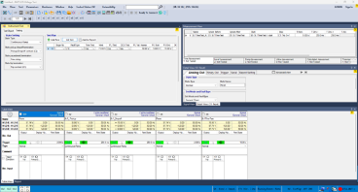
The Under/Over Voltage room is specifically designed for testing and evaluating the performance of voltage protection relays. It enables precise simulation of voltage sag and swell conditions across various ranges and examines the relay’s response to these conditions.
The user can accurately execute the required tests by defining the number of stages, function types, thresholds, time delays, and trip/close conditions. The system records the relay’s response in real time as voltage changes occur, then analyzes the results in a structured manner and presents them in tables and plots.
This room supports testing relay performance under diverse load and voltage conditions and serves as an effective tool for assessing relays in accordance with voltage protection standards in transmission and distribution networks.

Special features of the AMT205

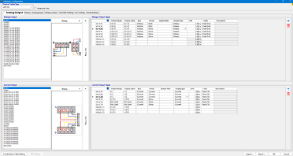
AMT 205—as an advanced tool for testing and simulating protection equipment—offers specialists a number of standout capabilities. Key features include:
1.Source Type Switching (current/voltage)
This feature lets the user configure each channel as either a voltage source or a current source. Such flexibility expands the device’s applicability for testing various protection devices, especially when simulating different fault conditions in power networks.
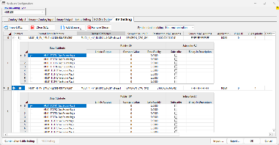
2.Per-source Display Type
For each source, you can switch the on-screen display between voltage value and current value. This improves usability and monitoring accuracy of electrical parameters during tests.
3.Per-source Scaling Factor
You can apply scaling factors to adjust output signal levels. This is essential for simulating equipment behavior at different scales or aligning precisely with the characteristics of measurement coils such as the Rogowski Coil.
4.Virtual sources and virtual binary/analog I/O
The device supports defining up to 128 virtual binary inputs and outputs, and can publish and subscribe to a large number of GOOSE frames. A real or virtual binary output can be linked to multiple attributes to simulate and test various protection scenarios in real time.

Rogowski coils

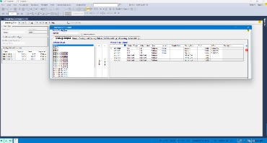
Rogowski coils are used to measure fast, transient AC currents and are widely employed in modern protection equipment. Proper testing of these coils requires signal sources with high accuracy, suitable stability, and immunity to electromagnetic noise.
The AMT 205, leveraging advanced internal circuit design, precise signal filtering, and inter-channel isolation, can generate highly accurate and stable waveforms. In addition, the use of up-to-date technologies in the power-supply and control circuitry provides very high resistance to environmental interference—making it fully suitable for sensitive tests such as simulating high-current fault conditions using a Rogowski Coil.

IEC 61850 protocol

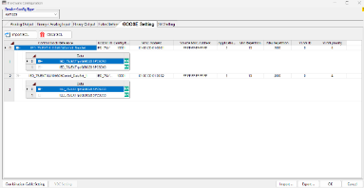
The AMT 205, with a focus on the current needs of protection-system engineers, provides advanced capabilities for the IEC 61850 protocol—especially SV (Sampled Values) and GOOSE messaging.

•GOOSE(Generic Object Oriented Substation Event)

This device supports defining up to 128 virtual binary inputs and outputs and enables the publishing (Publish) and subscribing (Subscribe) of a large number of GOOSE frames. A real or virtual binary output can also be linked to multiple attributes so that various protection scenarios can be simulated and tested in real time.
Leveraging the precision and speed of the AMT 205, instantaneous sending and receiving of GOOSE frames under real operating conditions is possible, providing a powerful tool for evaluating and verifying the correct operation of relays and protection systems.

•SV(Sampled Value)

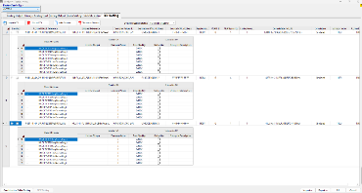
AMT 205, with support for IEC 61850-9-2 and IEC 61850-9-2LE, provides advanced capabilities for Sampled Value (SV) simulation and testing.
The device can create and manage up to 10 SV streams and allows defining up to 8 ASDUs per packet.
In Publish mode, you can link up to 20 attributes to real and virtual analog outputs and publish them precisely under the cited protocols.
In Subscribe mode, the device can receive, capture, and analyze up to 10 SV streams via virtual analog inputs.
Together, these features make the AMT 205 a powerful tool for testing Sampled Value–based equipment, enabling comprehensive evaluation of operational scenarios in protection and measurement systems.

