Introduction
























Vebko, with the goal of expanding its engineering services and technical support internationally, has established a broad network of 22 active representatives worldwide. This network is designed and developed to give customers easier access to sales, training, after-sales services, and specialized technical support. Vebko’s official representatives operate across Asia, Europe, Africa, and South America, and—leveraging experienced, well-trained experts—maintain direct contact with the company’s headquarters to ensure the highest levels of coordination, support, and service quality for customers. Building this international structure is a significant step toward realizing Vebko’s vision of becoming a trusted, reputable brand in the field of power-system testing and measurement equipment. The company’s extensive representative network not only simplifies communication with customers around the world, but also provides an effective platform for specialized training, consulting services, and local support—so that customers can benefit from Vebko’s standardized, integrated services in the shortest possible time.

Australia

Turkey

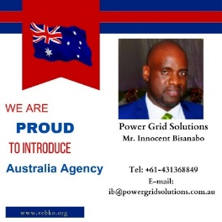
Power Grid Solutation Innocent Bisanabo
Direct contact information:
Mr. Innocent Bisanabo
Tel: +610431368849
Email: ib@powergridsolutions.com.au
Website: www.powergridsolutions.com.au
Linkedin: https://www.linkedin.com/in/innocent-
bisanabo-2b7a0b5/
Address: BTP Hub, 3 Clunies Ross Court, Eight
Mile Plains QLD 4113
Bailey Sam Vebko
Mr. Javad Yousefi
Mobile: 00905539121772
Email: baileysamturkey@gmail.com
Email: javadyousefi@gmail.com

England

Brazil
EM Enterprise International Ltd
Direct contact information:
Mr. Edward Mowbray
Tel: +447985380309
Email: edward@emeiltd.co.uk , Emowbray.emei@outlook.com
Linkedin: https://www.linkedin.com/in/
edward-mowbray-engtech-miet-6994bb38/
, https://www.linkedin.com/in/vebko-uk-8b3766225/
Address: 33 Bradford Road,Boston, Lincolnshire,PE21 8BJ



TDM PROTECTION & CONTROL
Direct contact information:
Mr.Waldery Souza
+55 11 98448-2693
waldery.souza@tdmservicos.com.br
https://tdmservicos.com/
https://www.linkedin.com/company/
tdmservicostecnicos

Iraq

Indonesia
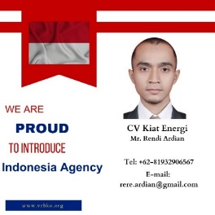
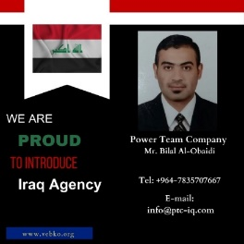
CV Kiat Energy
Direct contact information:
Mr. Rendi Ardian
Tel: +6281932906567
Email: rere.ardian@gmail.com
Linkedin Address: https://www.linkedin.com/in/rendi-ardian-38b64b44/
Address: Gd. Senatama Lt. 2 R209, Jl. Kwitang Raya No.8 RT001 / RW007,
Kwitang – Senen, Jakarta Pusat 10420, Indonesia

Power Team Company
Direct contact information:
Mr. Bilal Al-Obaidi
Tel: +964 783 570 7667
Email: info@ptc-iq.com
Website: www.ptc-iq.com
Address: Palestine Street, Baghdad, IRAQ

Morocco
Nigeria


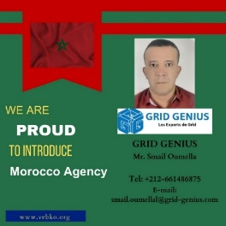
GRID GENIUS
1 Bd LAGHOTA SIDI MOUMEN RESIDENCE
ALYASSAMINE N B110 Casablanca , Maroc
email: smail.oumellal@grid-genius.com
mobitel: + 212 6 61 48 68 75
Mr.Smail OUMELLAL (General Manager)

Mr. Adeodun Soji Tayo
Direct contact information:
Mr. Adeodun Soji Tayo
Tel: +2348039565491
Email:Soj3az@yahoo.com
Linkedin Address: https://www.linkedin.com/in/adeodun-
soji-tayo-9260b25b/
Address: Kuje FCT-Abuja, Nigeria

South Africa

Philippines

Tebnox
Direct contact information:
Mr. Teboho Galela
Tel: +27 61 266 3968
Email: galelatc@tebnox.co.za
Linkedin Address: https://www.linkedin.com/
in/teboho-galela-44080193/
Address: 35 Rainbow Avenue, Farramere, Benoni,
1501, Gauteng, South Africa.

EXE Engineering Services and Solutions.
Address : G/F Kaizen Building 4H Abellana Extension, Basak, Mandaue City, Cebu Philippines, 6014
Contact : Edgar Cabatingan
email: emc@exepowercorp.com
Tel.: +63 917 688 8630



India

Thailand
NS POWER TEST SOLUTIONS.
Direct contact information:
Mr. Nikunj Dave
Mobile: +91 96012 82133
Email: info@powertest.in , j.panchal@powertest.in
Website: www.powertest.in
Address: B-618, Shalin Square, Hathijan Circle, Vinzol,
Ahmedabad, Gujarat, India- 382445.

EICA CO, Ltd
Direct contact information:
Mr. Thanis Sribovornmongkol
Mobile: +66 (0) 98 715-1488
Tel: +66 (0) 95 368-0844
Fax: +66 (0) 2 117-1458
Email: engineering@eica.co.th
Address: 55/3 Ram-Intra 34 Yeak 20 Tha-Raeng,
Bang Khen, Bangkok, THAILAND 10220


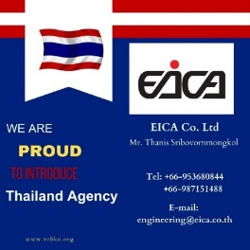

Bahrain

Croatia


Bahrain Agency
Edsar Technical Services and Trading Wll
Mr. Sarun Nambradath
Tel: +97333199120
Email: info@edsartech.com
sarun.n@essartech.com

Geneko d.o.o
Direct contact information:
Mr.Josip Jaman
+385 99 479 4901
geneko.vu@gmail.com
ddrmic13@gmail.com
josipjaman@gmail.com
https://https://geneko.hr/en/homepage//

Oman
Uruguay

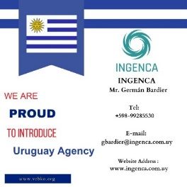
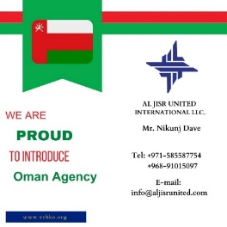
Oman Agency
AL JISR UNITED INTERNATIONAL LLC.
Mr. Nikunj Dave
Tel: +971585587754
+96891015097
Email: info@aljisrunited.com

Oman Agency
AL JISR UNITED INTERNATIONAL LLC.
Mr. Nikunj Dave
Tel: +971585587754
+96891015097
Email: info@aljisrunited.com

Saudi Arabia

Vietnam

Communication and Power Systems Company Limited(CAPSCO)
Contact information:
Manager- Mr. MohammadAsif Thakor +966 54 620 2194
+971 58 558 7754

Director: Mr. Abdul kalam Azad +971 55 390 4711
Sales engineer: AFAQUE KAZI +966 54 273 2251
Email: info@capsco.org
Address: P.O. Box- 1245, 25th Riyadh Street, Thouqba, Khobar-
31952, Kingdom of Saudi Arabia

Vietnam Agency
NHAT HA ELECTRIC
Mr. Quan Nguyen
Tel: +84906650110
Email: sale@nhatha-electric.com
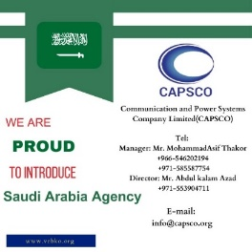

Pakistan

U.A.E
TQUIPMENT Accurate Measuring And Testing Equipment
TQUIPMENT Co Mr.Waqar
Tel: +92-3274961920 +92-3188700069
E-mail: sales.tquipment@gmail.com

Nikunj Dave +971 058 558 7754
POWERTEST
Power Testing Solutions
Business Centre, Sharjah Publishing City, Sharjah, United Arab Emirates.
info@powertestae
www.powertest.ae
Power Test Solutions
Mr. Nikunj Dav Tel: +971-585587754 +91-9601282133
Email: info@powertest.ae


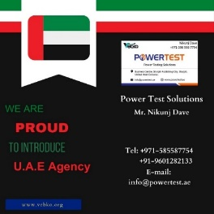

Armenia

Malaysia
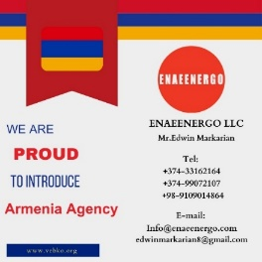
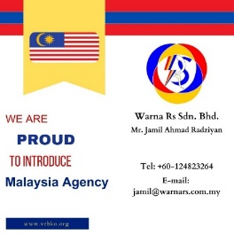
ENAEENERGO LLC
Mr.Edwin Markarian
Tel: +374-33162164
+374-99072107
+98-9109014864
Email: Info@enaeenergo.com
Edwinmarkarian8@gmail.com

WARNA RS SDN. BHD.
Direct contact information:
Mr. Jamil Ahmad RadziyanTel: +60124823264
Email: jamil@warnars.com.my
Address: No. 5, Bgn. Perniagaan Taman
Desa Meranti Indah,Padang Temusu,
08000 Sungai Petani,Kedah, MALAYSIA

Algeria
Areixer Algerie
Mr.Guendouz Abdelaziz
Tel: +213-549572988
+33-614535524
Email: aguendouz@arixet-dz.com



