Introduction

Among the most fundamental needs of engineers in the field of protection and testing of electrical equipment are precise current and voltage injection devices as well as high-accuracy measurement tools. These instruments play a key role in performing tests and evaluating the performance of critical power-system equipment.
In addition, engineers and specialists involved in the manufacturing, maintenance, and servicing of industrial equipment and high-voltage substations require reliable, accurate tools to carry out tests in accordance with international standards. These tests include examinations of equipment such as power transformers, circuit breakers, disconnectors, current transformers (CTs) and voltage transformers (VTs) across various classes, as well as reactors and capacitor banks.
Drawing on the valuable experience and deep technical expertise of its team, Vebko has succeeded in designing and producing devices that integrate multiple capabilities into a single, unified multi-purpose instrument—significantly reducing the size, weight, and number of devices required, and yielding substantial savings in procurement and maintenance costs for industrial and laboratory environments.
Beyond improving accuracy, repeatability, and test speed, these solutions also enhance the safety and efficiency of the testing process. For this reason, Vebko’s modern test systems are an effective and attractive replacement for traditional, fragmented setups.
Given the broad scope of applications for Vebko’s test devices, a set of accessories and auxiliary tools is also available, including various cables, interfaces, terminals, probes, and adapters, enabling the required connections with the highest levels of safety, accuracy, and electrical stability.
These accessories are offered as dedicated kits, allowing specialists to choose the most appropriate configuration according to test type, operating voltage, and the size of the device under test. This modular design increases ease of execution and provides high flexibility in industrial and laboratory settings.

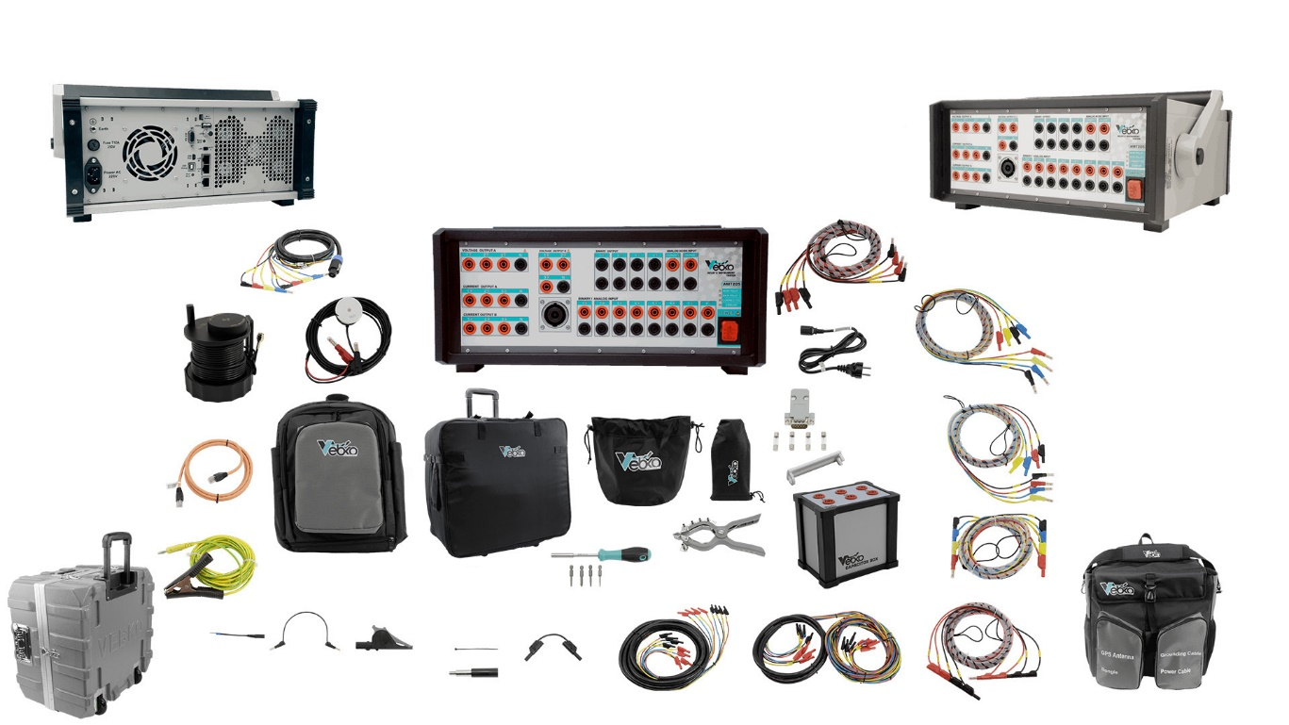

 | Description | Code | QTY
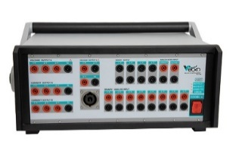 | Test device with 4 voltage sources and 6 current sources.  8 binary/analog inputs.  2 AC/DC analog inputs.  4 binary outputs.  LAN / Wi-Fi / Serial connectivity.  Weight: 12.5 kg.  Dimensions: 39 cm × 41 cm × 19 cm | AMT1003 | 1
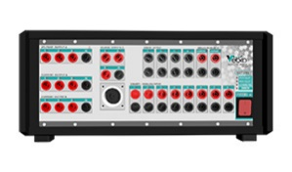 | Test device with 6 voltage sources and 6 current sources.  8 binary/analog inputs.  2 AC/DC analog inputs.  4 binary outputs.  LAN / Wi-Fi / Serial connectivity.  3 network ports.  Convertible current and voltage sources.  Weight: 12.5 kg.  Dimensions: 39 cm × 41 cm × 19 cm | AMT2050 | 1
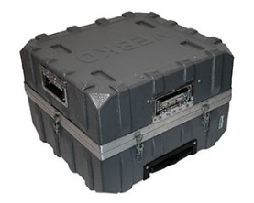 | Protective relay tester carry case for safe transport of the device | AMT1001 | 1
 | Test clamp suitable for various power equipment, with 4 current pins and 1 voltage pin | AMT1016 | 8
 | Protective cover for the test clamp | AMT1028 | 8
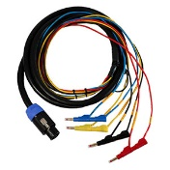 | 8-core, 4-color, 3-meter cable for easier connection between the device and the relay, rated 300 V and 32 A per core | AMT1004 | 1
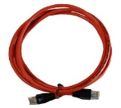 | RJ45 cable for connecting the device and the laptop | AMT1007 | 1
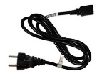 | Device power cable  Length: 1.5 m  250 V, 10 A | AMT1006 | 1
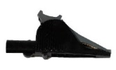 | Alligator clips for connecting to pins or screws during equipment tests | AMT1012 | 4
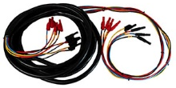 | 7-meter, 8-core cable suitable for equipment testing | AMT1015 | 3
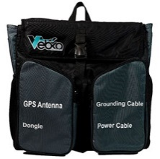 | Soft carry bag for the device, with compartments for accessories | AMT1002 | 1
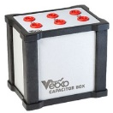 | Box containing 3 non-polar capacitors, 10,000 µF and 60 V | AMT1019 | 1
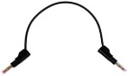 | Flexible test lead with plastic insulation for safe use on test terminals | AMT1011 | 4
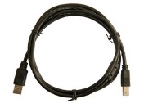 | USB Type-B to USB Type-A cable | AMT1026 | 1
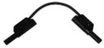 | Flexible test lead with plastic insulation for safe use on test terminals | AMT1014 | 4
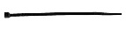 | Black cable ties | AMT1013 | 5
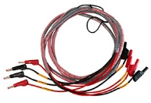 | 3-meter, 4-core two-color cable suitable for relay and equipment testing | AMT1005 | 5
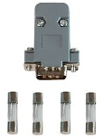 | RS-232 dongle and protective fuse for the device | AMT1020 | 1
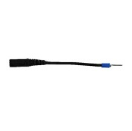 | Flexible terminal adapters for screw terminals | AMT1009 | 12
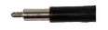 | Terminal adapters for screw terminals | AMT1010 | 12
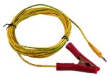 | Grounding cable suitable for the device | AMT1008 | 1
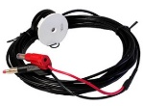 | Infrared optical sensor for meter testing | AMT1018 | 1
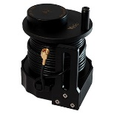 | GPS antenna for syncing multiple devices, length 15 m | AMT1017 | 1
 | Backpack for carrying cables and test clamps | AMT1023 | 1
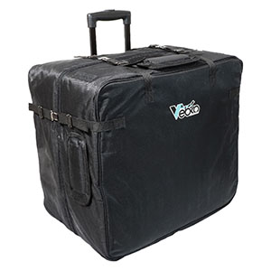 | Suitcase cover for the device to protect it during air and intercity transport | AMT1024 | 1
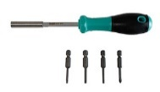 | Screwdriver for opening the device (if needed) | AMT1022 | 1
 | Black pouch for small equipment and cables | AMT1025 | 1
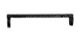 | Cable retainer for bundled cables | AMT1021 | 16
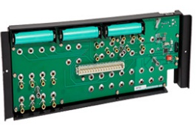 | instrument Base Plate | C01-AMT1030 | 1
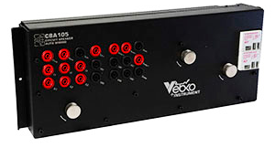 | Circuit breaker test module – CBA105 | C12-AMT1031 | 1
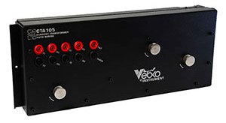 | CT & CVT test module – CTA105 | C13-AMT1033 | 1
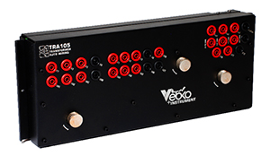 | Transformer test module – TRA105 | C11-AMT1032 | 1
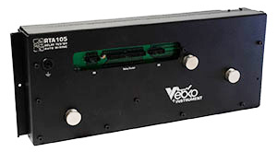 | Electronic Relays Tester Module – RTA105 | C30-AMT1047 | 1
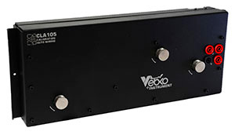 | Auto Calibration – CLA105 | C20-AMT1056 | 1
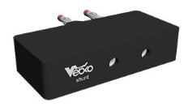 | BI shunt | C52-AMT1060 | 1
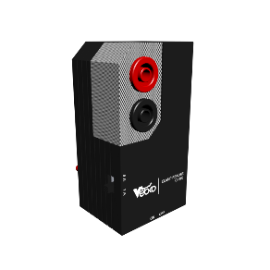 | Clamp Booster | C50-AMT1058 | 1
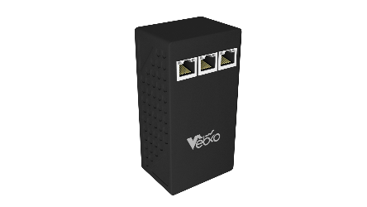 | Rogowski | C53-AMT1061 | 1
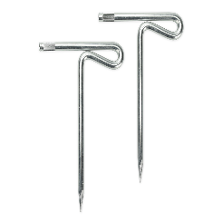 | Earthing Test Electrode | C60-AMT1063
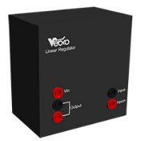 | Insulation Resistance Measuring | C40-AMT1051 | 1
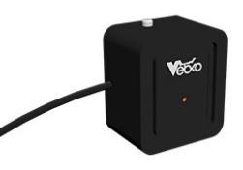 | Arc-flash initiator | C51-AMT1059 | 1
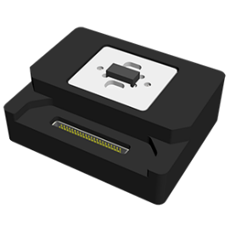 | G6A Relay | C31-AMT1055 | 1
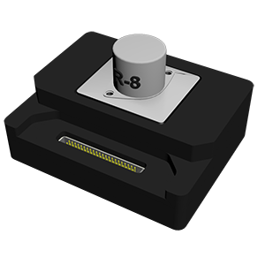 | P3C8 | C36-AMT1045 | 1
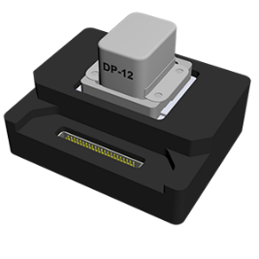 | DP12 | C32-AMT1041 | 1
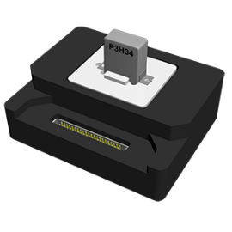 | P3H34 | C37-AMT1044 | 1
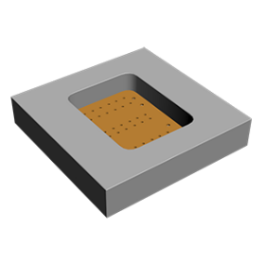 | DP12 Guide | C33-AMT2020 | 1
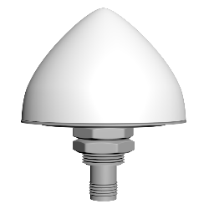 | GPS With 50 Meters Cable | C55-AMT1049 | 1
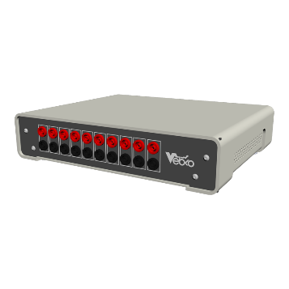 | Extended Binary | C56-AMT1065 | 1
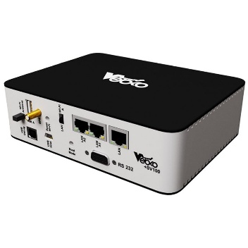 | Sample Value | C70-AMT1066 | 1
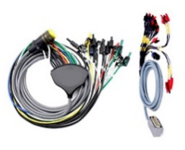 | Recloser Test Cable | C54-AMT1064 | 1

